BOPHELONG PRIVATE CLINIC
NETWORK DESIGN PROJECT(by EN BALOYI)

MILESTONE | Milestone 1 – client design review
CLIENT | BOPHELONG Private Clinic,Mahikeng
INDUSTRY | Healthcare
ADDRESSING BLOCK | 10.10.0.0/16
Technical challenge | VLANs-SWITCH based network segmentation
Design constraint | New file/application server planned within 6 months
Change request | CR 13- Public self-service kiosk,internet only access

The provided client design review for Bophelong Private clinic network project:the client requirements, the physical and logical topology ,the IP Addressing plan,

1.client requirements
client :bophelong private clinic,mahikeng
industry: Healthcare
assigned addressing block:10.10.0.0/16
requirement
Addressing block | 10.10.0.0/16
Technical Challange | VLANS-switch based network segmentation
Design constraint | Design must accommodate a new file/application server within 6 six months
Change request(CR13) | Public self self service kiosk at reception,internetaccess only- no access clinic resources
Funtional requirements | Interswitch communication between relevant nodes

Interpretation
The clinic network is designed around four primary functional groups
.administaration
.medical/clinical staff
.reception
.a separate VLAN for the planned new server

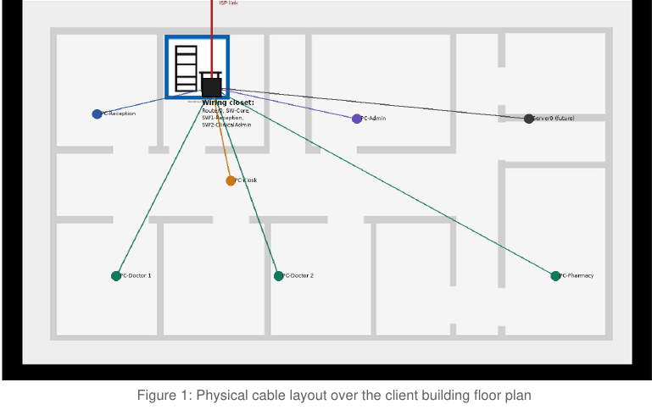
2. Physical Topology
The physical topology follows the clients direct building plan -the topology is not abstrated from real-world physical layout.The switch,router and other infrastructure are placed in the buildings existing wiring closet ro meet standard practices for structured cabling .Every room is wired back to thye closet in a start topology.

Cable run | To/from | purpose
ISP link | External | To/from Router(0) WAN interface
Reception | Reception room | PC-Reception via SW1-Reception
Kiosk | Central corridor | CR13 public kiosk via SW1-RECEPTION
Admiistration | Admin office | PC-admin via SW2-Clinical admin
Server room | reserved back room | Server(0) direct to SW-CORE
Consultation rooms | Botton-row rooms | PC-Doctor ½ via SW2-Clinical admin
Pharmacy | FAR RIGHT room | PC-Phamarcy via SW2-Clinical admin

By placing all switches in the same closet,the cabling is optimized.in poarticular ,the reserved server room only needs an additional short cable run when the derver is installed the is no need for a second closet or backbone cabling

3.logical topology
Router is used for VLAN routing using the router-on-a stick method :a trunk link carries traffic from all the VLANs to the Distrubution switch , while Routers(0)s interface are configured as subinterfaces with VLAN tages .Router0 handles traffic for all VLANs on tagged ports and acts as a default gateway.

Routers0 manages VLAN gateways (SVI-equivalent subinterfaces) and CR13 ACL is applied to the VLAN 66 subinterval

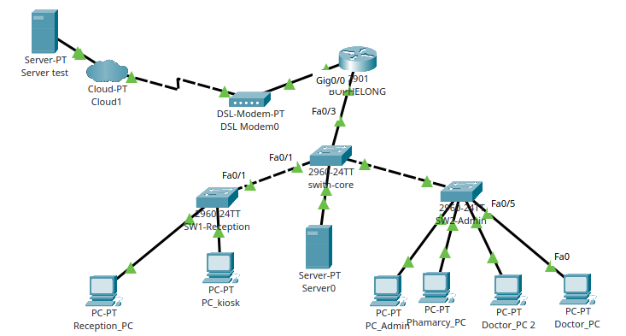
Logical VLAN Topology

VLAN | NAME | Pursose
10 | Administration | Admin/office staff
20 | Medical staff | Doctors,nurses,access to clinical records
30 | Reception | Reception desk Staff devices
40 | servers | For the new file/application server
66 | Guest kiosk | CR13-Public self service kiosk,interne4t only
99 | Management | Switch/router management,native VlAN

HOW TO DESIGN ADRESSES(BRIEF)
1.VLAN challenge :sic VLANS are configured with inter-VLAN routing on Router0 which can be seen in the (show Vlan bried),(show ip interface brief) and VLAN pings
2,six months server constaints :VLAN40 IS available for the new server as its subnet exists and the server room is physically reserved
3.CR13-kiosk : VLAN 66 is isolated with an extended ACL on Rounter (0) allowing the internet only boud traffic while denying acces to 10.10.0.0/16 making it innaccessible to other clinical resources

4.ip ADDRESSING PLAN
The base block 10.10.0.0/16 is divided into 24 subnets for each Vlan-each subnet allows 254 hosts which is more that enough for the small private hospital and leaves rooms for future expantions

VLAN | NAME | SUBNET | GATEWAY | DHCP
10 | Administration | 10.10.10.0/24 | 10.10.10.1 | yes
20 | Medical staff | 10.10.20.0/24 | 10.10.20.1 | yes
30 | Reception | 10.10.30.0/24 | 10.10.30.1 | yues
40 | servers | 10.10.400.0/24 | 10.10.40.1 | static
66 | Guest kiosk(CR13) | 10.10.66.0/24 | 10.10.66.1 | yes
99 | Management(native) | 10.10.99.0/24 | 10.10.99.1 | static

DESIGN notes
1.VLAN is currently empty to accommodate the server within 6 months without redesign.
2.VLAN (Kiosk) is protected by an exdended ACL on Rounter(0);permits internet-bound traffic,deny 10.10.0.0/16,permit all traffic out . The ACL is evidence for CR13 which will be tested by attempting to ping from VLAN 66 to another VLKAN while a web request succeeds.
3.VLAN99 is set as a native VLAN on the trucks instead of the default VLAN1 management traffic.

